# Write a letter to your friend mentioning some ways to conserve water​.

# SAMPLE ANSWERS:

# 

Well, you all must be aware of the wonders that water does for us, isn’t it? Of course yes. So, it is quite obvious that we all are aware that water is the base and soul of life. It is important to use water judiciously and not waste it. Life without water is impossible. Also, the drinkable water is quite low and if we continue to wastewater at the speed we do today, the day is not far when we will have to fight for water. But still, let me ask you one question, are we actually working in the direction of saving water? The rightful answer would be no. Even after knowing the value of water, we still are abusing or rather say wasting water. This needs to be changed.

As we all are aware that, water is a perishable resource. It gets depleted every time we use it and needs time to get replenished. Lack of water can lead to problems like famine and drought. It is not just required for drinking or household activities but also for economic activities. Right from agriculture to industries every sector needs water to produce and provide. Water conversation which is a motto today can be seen only on papers, books, and journals. The real-life implementation is yet to start.

But how can you save water? Let me introduce you to some very basic and primary ideas to save water. First, do not let your tap run while brushing, it could save a lot. Domestically, install, and check for leakages on time to time so that not a single drop of water is wasted. We also need to educate our children, community members, and others about safe water-using habits. Installing a water harvesting system can help you to save water and also can increase the ground level of the water. In the commercial sector like agriculture, the use of sprinklers and modern methods of harvesting can save a lot of water as compared to traditional methods. Industries should try to reuse and recycle the water, rather than just discharging the used and dirty water in the lakes and rivers around. Further, planting trees will help us as they bind the soil and bring on the rainfall.

Social media has a global reach. What is posted on social media is seen by millions? So, try reaching the people on social media and use this platform as a strong tool to make people aware of the importance and techniques to save water. Water is undoubtedly the sacred gift of nature and we should all ensure that it is used wisely. No matter you are rich or poor; water is a necessity for you.

Saving water is not the responsibility of only you or me or for that sake any single individual. But on the contrary, saving water is a national cause and should be a common practice. To conclude, I would just like to add that, when you are thirsty, you do not search for any other beverage or treasure, but water. This itself is enough to explain why we need to save water.

I would like to end this with a note that let us today all take a vow to be diligent and make others diligent too, and move ahead on the road of saving water.

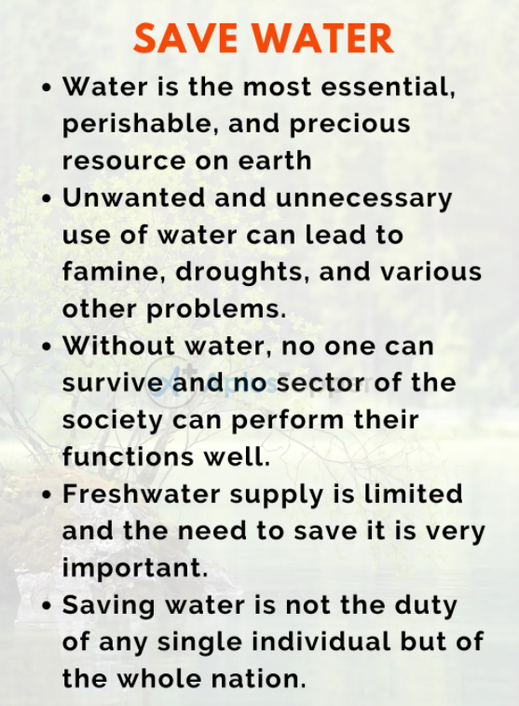

# how to write a convincing / persuasive email or letter

# As the name suggests, a persuasive letter is written to persuade a reader to invest time or resources in a particular product or event.

# to convince the reader to do their bit for a cause (food for all or global warming, for example). The very meaning of persuasive says that the letter has to be convincing enough for the reader to respond in the positive and take almost immediate action. A persuasive letter is a formal document and requires to be written in a specific format so that it fulfills its function well.

# In a persuasive essay, it’s the writer’s job to convince the reader to accept a particular point of view or take a specific action. Persuasive essays require good research, awareness of the reader’s biases, and a solid understanding of both sides of the issue. A good persuasive essay demonstrates not only why the writer’s opinion is correct, but also why the opposing view is incorrect.

### Persuasive Essay Outline

#### **Introductory Paragraph**

* Grab the reader’s attention by using a “hook.”
* Give an overview of the argument.
* Close with a thesis statement that reveals the position to be argued.

#### **Body Paragraphs**

* Each body paragraph should focus on one piece of evidence.
* Within each paragraph, provide sufficient supporting detail.

#### **Opposing View Paragraph**

* Describe and then refute the key points of the opposing view.

#### **Concluding Paragraph**

* Restate and reinforce the thesis and supporting evidenc

# <https://study.com/academy/lesson/how-to-write-a-persuasive-letter-planning-format.html>

## Persuasive Letter

Think of the last time you were in an argument. Think of how you tried to convince another person that you were right. Were you successful? No? What worked? What didn't?

At one time or another, we're all in the same position: We're trying to convince someone else to do something or agree with us. This is called **persuasion**.

One way to use persuasion is via writing a letter. However, you'll only be convincing if you learn how to carefully craft persuasive letters. This lesson discusses the basic guidelines of planning and formatting a persuasive letter.

## Planning

Before you can begin writing your letter, you must first plan. Without proper preparation, you run the risk of sounding like a complainer. Avoid this at all costs!

With that in mind, consider the **tone** of your letter, which is the general attitude you project in a piece of writing. Your goal is to get the reader to agree with you or to take a specific action, so your tone must be mature and logical.

Consider the following example. Imagine you were trying to persuade your mom that you can't clean your room. Look at these two possible attitudes you can take:

* Mom, I can't clean my room because it's so boring.
* Mom, I have a huge science exam tomorrow morning that is worth half my grade. I have to spend all night studying. My room is not the highest priority right now.

Which one sounds more mature and logical? The second one of course! The first one is not convincing because the tone is immature. It is merely a complaint and does not use logic.

## Support

After considering your tone, plan the **support**, which is the evidence or proof that your opinion is correct. Think of reasons that support your opinion. To make a strong argument, you should have at least two to three separate ideas to back up your opinion.

Once you have these reasons, think of examples to prove each idea. Then ask yourself which idea has better examples. This is the one you should plan on writing first in your letter. Then move on to your second strongest support, and finally end with your weakest.

Another strategy to make a strong argument is to include the **counterarguments** which are the reasons why your opinion is wrong. That might seem illogical, but if you address these concerns, you are more likely to persuade your reader. Acknowledging the side you don't agree with shows you are reasonable and rational. Then all you have to do is state why the counterarguments are still erroneous.

Let's look at an example to see how this works. Imagine your argument is that students should only go to school 4 days per week. One counterargument is that parents might be unable to provide child care for their children on Fridays if there is no school.

# 

# (100-150 words)

# 

# 

# Write a email to your friend describing your favourite tv programme / Write a letter to your friend telling him about the television programme you like the most. Also write why you like it.

# Dear ..............              Hello! How are you! We are happy here and hope the same for you. I received your letter recently. You wanted to know about my favorite TV program. There is a flood of T.V. serials these days because of multichannels. But all programs are not of same standards. My favorite program is “Balika vadhu” of “colours “channel. It raises an important social issue-the child marriage. In many parts of India child marriage is still practiced. Children are married in very small age. This not only affects their education but spoils their whole life. Through the story of “Anandi” this serial depicts the problems emerged in this system. Only stringent laws can’t stop the child marriage. Public awareness is necessary. Government should focus on the education especially adult education in the backward areas where problem is more rampant. By making this kind of series T.V can play very important role is social awakening. Please convey my regards to uncle, aunty and love to Chintoo. Yours loving ..........................

# 

# <https://www.ieltstutor.me/blog/letter>

# <https://www.ieltsbuddy.com/informal-ielts-letters-writing-to-a-friend.html>